**Section 2–1B: More Functions**

A **function rule** is an equation that represents an output value in terms of an input value. You can write a function rule in **function notation**. Shown below are examples of function rules.

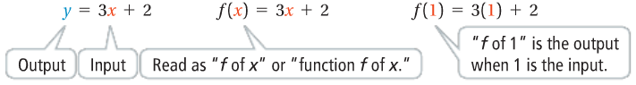

The **independent variable**, *x*, represents the input of the function. The **dependent variable**, *f*(*x*), represents the output of the function. It is called the dependent variable because its value depends on the input value.

**Example 1: Using Function Notation**

For $f\left(x\right)=-2x+5$, what is the output for the inputs, $-3$, $0$, and $\frac{1}{4}$?

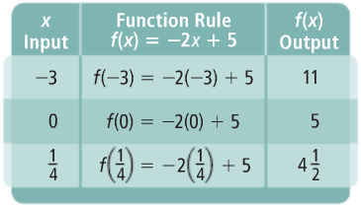

To model a real-world situation using a function rule, you need to identify the dependent and independent quantities. One way to describe the dependence of a variable quantity is to use a phrase such as, “distance is a function of time.” This means that distance ***depends*** on time.

**Example 2: Writing and Evaluating a Function**

You are buying bottles of a sports drink for a softball team. Each bottle costs $1.19. What function rule models the total cost of a purchase? Evaluate the function for 15 bottles.

Cost is the dependent quantity and the number of bottles is the independent quantity.

**Relate: Total Cost** Is **Cost Per Bottle** Times **Number of Bottles Bought**

**Define:** Let *b* = number of bottles bought.

Let *C*(*b*) = the total cost.

**Write:** *C*(*b*) = 1.19 ‧ *b*

$C\left(b\right)=1.19b$ Substitute 15 for *b*.

$C\left(b\right)=1.19∙15$

$C(b)=17.85$

**Result:** The cost of 15 bottles is **$17.85**.